**Wave shoes Sales Dashboard:-**

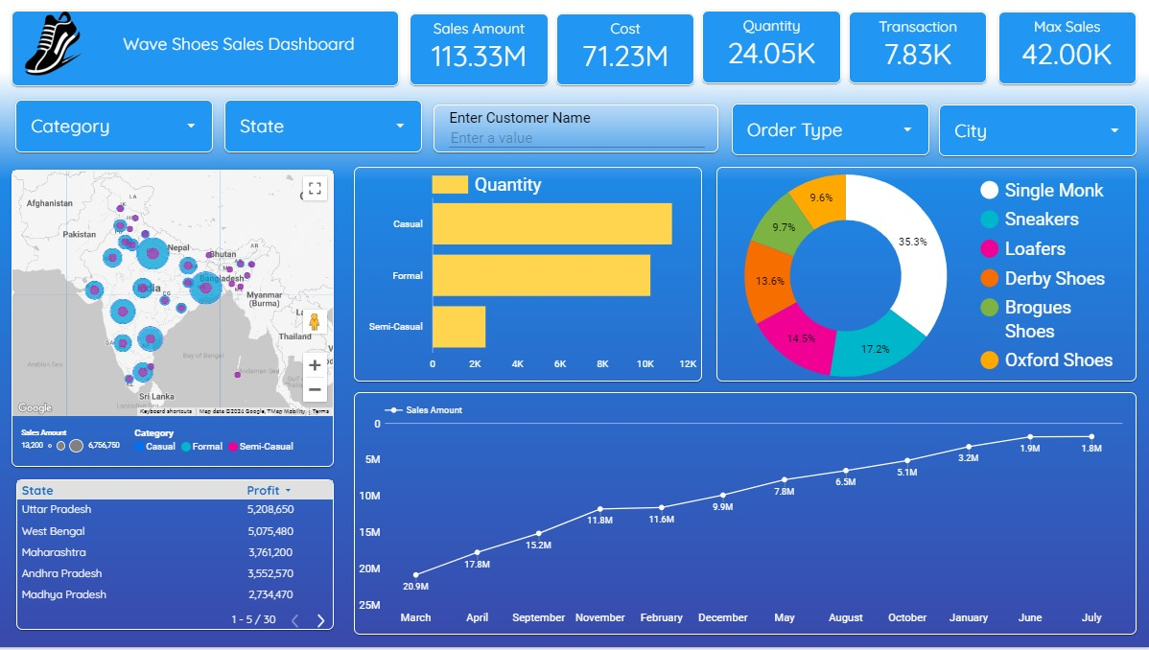

**Wave Shoes Sales Dashboard insight**

**1. Overview of Key Metrics**

* **Total Sales Amount**: ₹113.33 million
* **Total Cost**: ₹71.23 million
* **Total Quantity Sold**: 24,050 units
* **Total Transactions**: 7,830
* **Maximum Sales by a Single Category**: ₹42,000

**Observation**: The overall sales performance is strong, with a significant profit margin when considering the difference between sales amount and cost.

**2. Sales Distribution by Category**

* **Casual Shoes**:
  + Highest in quantity sold with around 12,000 units.
* **Formal Shoes**:
  + Second highest, with around 9,000 units sold.
* **Semi-Casual Shoes**:
  + Least popular, with fewer than 3,000 units sold.

**Observation**: Casual shoes are the most popular category, indicating a preference for casual footwear among customers.

**3. Sales by Shoe Type (Pie Chart)**

* **Single Monk**: 35.3%
* **Sneakers**: 17.2%
* **Loafers**: 14.5%
* **Derby Shoes**: 13.6%
* **Brogues Shoes**: 9.7%
* **Oxford Shoes**: 9.6%

**Observation**: Single Monk shoes dominate the sales by shoe type, capturing more than one-third of the market. The variety in shoe types shows a diverse customer preference, but Single Monk clearly leads the market.

**4. Geographical Sales Distribution**

* **Top Performing States by Sales**:
  + **Uttar Pradesh**: ₹5,208,650
  + **West Bengal**: ₹5,075,480
  + **Maharashtra**: ₹3,761,200
  + **Andhra Pradesh**: ₹3,552,570
  + **Madhya Pradesh**: ₹2,734,470

**Observation**: Northern and Western states like Uttar Pradesh and West Bengal are top contributors to the overall sales, while states in other regions show moderate sales figures. This regional variation could guide marketing and distribution strategies.

**5. Sales Trend Over Time (Line Graph)**

* **Sales Growth**:
  + Steady increase in sales from March to July, with a notable jump in December (₹9.9M) and January (₹7.8M).
  + Sales peak in December, which might be due to holiday season demand.

**Observation**: The sales trend indicates consistent growth with significant spikes during the holiday season. The trend suggests that the brand's marketing efforts and seasonality play crucial roles in driving sales.

**6. Sales by Order Type**

* Detailed metrics are not provided in the image for this section, but this filter could be used to gain deeper insights into customer preferences by analyzing different ordering methods (e.g., online, in-store).

**7. City-wise Sales and Customer Input**

* The dashboard includes filters for city and customer name, allowing for more granular analysis, though specific data isn't visible in the screenshot.
* This could be useful for targeted marketing and personalized customer service.

**Conclusion**

The Wave Shoes Sales Dashboard provides a detailed look at sales performance across various dimensions—category, shoe type, geography, and time. Casual shoes and Single Monk shoes are the most popular categories and shoe types, respectively. The Northern and Western regions of India, particularly Uttar Pradesh and West Bengal, are major sales drivers. The sales trend suggests a successful seasonal strategy, particularly around the December holiday season.

For further actions, focusing on the underperforming regions and categories (like Semi-Casual shoes) could unlock additional revenue opportunities. Additionally, leveraging the insights from the order type and city-wise sales data can further refine marketing and sales strategies.